PearlMart Inventory Management System

Effort distribution of the student:
SID: 202004322 STUDENT NAME: Aljazi Alnoaimi Effort given 26%
SID: 202402767 STUDENT NAME: Dhuha Almalki Effort given 28%
SID: 202109373 STUDENT NAME: Buthaina Albaye Effort given 25%
SID: 202304572 STUDENT NAME: Aldana Al-Mamari Effort given 21%
Course: CMPS 310
Submission date: 18 October 2026
Theory Class section: L52

DECLARATION: We hereby certify that no part of this project or product has been copied from any other student’s work or from any other sources except where due acknowledgment is made in the project. No part of this project/product has been written/produced for us by any other persons.

1 Scope and submission status
PearlMart needs one inventory system for its warehouse and billing counters. We model how staff receive goods, maintain item records, order stock, complete sales, process replacements, record customer requests and obtain reports. The design aims to keep quantities and transaction records consistent.
The supplier is outside our system. We exchange order and invoice information with the supplier, but we do not design the supplier’s internal procedures. Customers communicate through staff; there is no customer self service interface in the scenario. Payment processing, payroll and supplier accounting are outside this milestone’s proposed scope.
Artifact | Report status | Final team check
Analysis and specifications | Completed and documented in the final report. | Requirements and four detailed use-case specifications included.
DFD and UML diagrams | DFD Level 0, Level 1, Level 2, Use Case Diagram, and Class Diagram completed. B12 review completed. | Diagrams included in the report and Visual Paradigm project; final version alignment to be confirmed in B16.
Visual Paradigm source | Native .vpp project opened successfully; five diagram types verified. | Confirm the uploaded .vpp matches the final Word report.
Scrum plan and issue drafts | B01–B15 completed and documented on GitHub. B16 is in progress. | Verify final Scrum Board status and release links after B16.
Reviews and evidence | Sprint 1 and Sprint 2 reviews documented. B14 diagram evidence uploaded to GitHub. | Confirm evidence links and supporting screenshots are accessible.
Team and repository details | Team names, student IDs, contribution percentages, and repository links recorded. | Contribution percentages approved by the team; verify the final repository commit.

How the supplied sources were used
Lab 2 provides the GitHub workflow. Lab 3 provides boundary analysis and the Level 0 convention. Lab 4 provides Gane–Sarson DFDs, decomposition and balancing. Lab 5 provides use case notation and relationship rules. The assignment itself requires four specifications and a complete class design; the supplied labs do not contain the class design lesson or the Blackboard specification template. We use only the fields listed in the assignment and basic object oriented design. Transfer the four specifications to the official template if it has extra fields.

2 Assumptions
The following modeling assumptions establish a consistent interpretation of the project scenario. Any requirement clarification can be incorporated into the corresponding model during subsequent development.
ID | Proposed assumption | Reason | Affected models
A01 | Staff permissions follow the role table in Section 3. All operations require a valid session. | The scenario says “authorized employee” without a complete access matrix. | All models
A02 | One inventory quantity is shared by the warehouse and counters. No location transfers are modeled. | The scenario describes one integrated inventory. | D2, Item, all stock operations
A03 | An item record has one expiry date. A receipt with a different expiry date is held for clarification before posting. | Multiple batches are not specified; confirm this simplification with the instructor. | UC03, UC09, Item
A04 | No stock is deducted for a draft sale. Final stock validation, deduction and sale recording occur together. | This meets cancellation and consistency requirements without reserving stock. | P4, UC10, UC11, SalesService
A05 | Discount and tax rates are approved configuration values; no legal rates are assumed. Tax applies after discount. | Rates and calculation order are unspecified. | UC10, PricingPolicy
A06 | Replacement is like for like, with a valid completed receipt and an unexchanged quantity. Resalable returns enter stock; unusable returns do not. | The store policy is unspecified. No refund or price difference is assumed. | P5, UC12, Replacement
A07 | Partial deliveries are allowed. Received quantities cannot exceed the outstanding order quantity. Duplicate invoice or receipt IDs are rejected. | Delivery and duplication rules need to be defined. | P3, UC09, procurement classes
A08 | Physical payment is confirmed by the Salesperson; payment gateways are outside scope. | The assignment requires billing and inventory, not banking integration. | UC10, SalesService
A09 | Expiry is checked against the store’s current date; an item with an earlier expiry date is expired and cannot be sold. | The exact expiry boundary is not specified. Confirm with the instructor. | P2, P4, Item
A10 | Summary reports support stock, expired items, orders, receipts, sales, cancellations, replacements and customer requests. | These are the recorded activities described in the scenario. | P7, ReportService

3 Requirements and responsibilities
ID | Required behavior
R01 | Authenticate users and allow password changes.
R02 | Add new goods and increase existing quantities.
R03 | Validate and remove goods without negative stock.
R04 | Find expired goods and allow their removal.
R05 | Search by identifier, barcode or name.
R06 | Update item information including selling price.
R07 | Record and send supplier orders.
R08 | Record supplier invoices and verified received quantities.
R09 | Validate sale quantities and calculate discounts, taxes and total.
R10 | Generate a receipt and deduct stock on successful completion.
R11 | Cancel a draft receipt without permanent stock deduction.
R12 | Verify replacements, record them and update stock.
R13 | Record and review requests for unavailable items.
R14 | Keep transaction history and generate summary reports.
R15 | Keep warehouse and counter information consistent.

Actors and proposed permissions
Actor | Responsibilities
Employee | Shared role: log in, change password and search items.
Administrator | Update item details and prices; request summary reports.
Inventory Manager | Add or remove goods, view expiry, create supplier orders, record and review customer requests, request reports.
Store Manager | Add or remove goods, view expiry, verify supplier receipts and request reports.
Salesperson | Process sales, cancel current receipts, process replacements and record customer requests.
Supplier | Receive purchase orders and provide goods and invoice details; no staff login.

4 Data flow model
Employee is a grouped external entity representing the four staff roles in Section 3. This keeps the context readable; it does not give each role every permission. The supplier is the other external entity. Goods, receipts and items are data, and scanners are devices, so they are not separate external entities.

Level 0 context diagram
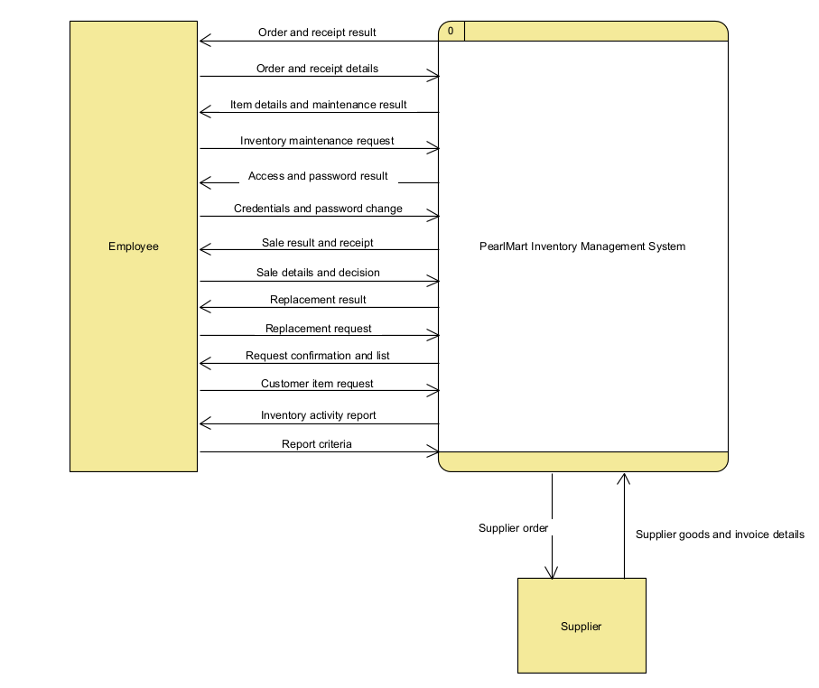
The context diagram represents the system as one process with external data flows. The Level 1 and Level 2 diagrams elaborate the internal processing and persistent data stores.

4 1 Processes and data stores
Process |  | Responsibility
1 Manage access |  | Verify login and password changes.
2 Maintain inventory |  | Search, add, remove, inspect expiry and update item information.
3 Manage procurement |  | Record orders, supplier invoice data and verified receipts.
4 Process sale |  | Validate, price, complete or cancel a customer sale.
5 Process replacement |  | Validate and record an item replacement.
6 Manage customer requests |  | Record unavailable item requests and retrieve them for review.
7 Generate reports |  | Read inventory and transaction history to prepare summaries.
Store | Contents |  | Read by | Written by
D1 Users | Credentials and role |  | 1 | 1
D2 Items | All specified item fields, quantity and optional expiry |  | 2 3 4 5 7 | 2 3 4 5
D3 Procurement | Orders, order lines, invoices and verified goods receipts |  | 3 7 | 3
D4 Sales | Completed or cancelled sales and line price snapshots |  | 5 7 | 4
D5 Replacements | Original sale reference, quantity, disposition and status |  | 5 7 | 5
D6 Customer requests | Requested item description, quantity and date |  | 6 7 | 6
D7 Activity records | Actor, date, action, source reference and stock changes |  | 7 | 2 3 4 5 6
P6’s incoming customer item request also carries review criteria; P6 returns either confirmation or the request list. P2’s maintenance request carries the action type, item lookup or item fields, quantity and reason as applicable. P3 receives the employee’s order data or physically verified receipt details; the supplier’s separate input carries invoice and ordered goods information.

4 2 Level 1 view 1
These four views form one Level 1 DFD. Repeated Employee and store symbols are references to the same entity or logical store. The complete tall drawing is supplied as 02-level1-full.svg and PNG. Each process communicates through the shared stores; no direct store to store flows exist.
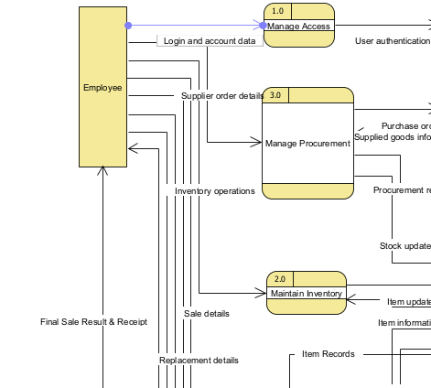
Notation: rounded process with number compartment, rectangular external entity, open ended store with identifier compartment, and a separate arrow for each read or write.

4 2 Level 1 view 2
These four views form one Level 1 DFD. Repeated Employee and store symbols are references to the same entity or logical store. The complete tall drawing is supplied as 02-level1-full.svg and PNG. Each process communicates through the shared stores; no direct store to store flows exist.
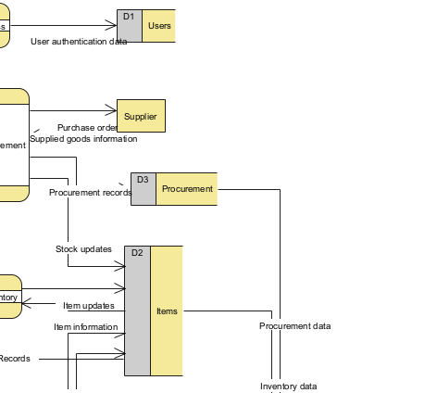
Notation: rounded process with number compartment, rectangular external entity, open ended store with identifier compartment, and a separate arrow for each read or write.

4 2 Level 1 view 3
These four views form one Level 1 DFD. Repeated Employee and store symbols are references to the same entity or logical store. The complete tall drawing is supplied as 02-level1-full.svg and PNG. Each process communicates through the shared stores; no direct store to store flows exist.
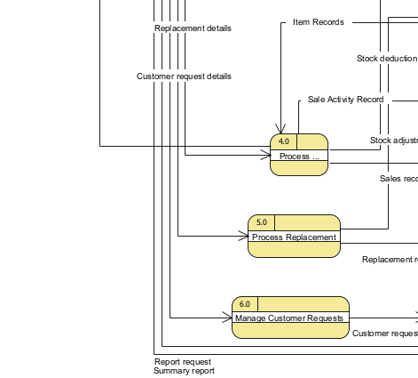
Notation: rounded process with number compartment, rectangular external entity, open ended store with identifier compartment, and a separate arrow for each read or write.

4 2 Level 1 view 4
These four views form one Level 1 DFD. Repeated Employee and store symbols are references to the same entity or logical store. The complete tall drawing is supplied as 02-level1-full.svg and PNG. Each process communicates through the shared stores; no direct store to store flows exist.
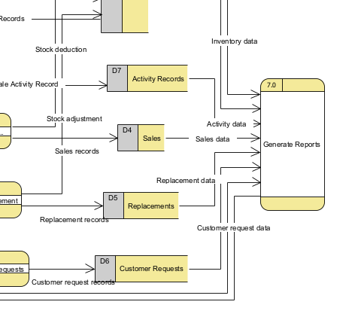
Notation: rounded process with number compartment, rectangular external entity, open ended store with identifier compartment, and a separate arrow for each read or write.

4 3 Context balancing checklist
Each row preserves the exact data name and direction. “0” is the context process; the Level 1 endpoint identifies the responsible child process.
Context flow | Level 1 endpoint | Check
Employee → Credentials and password change → 0 | 1 | Matches
0 → Access and password result → Employee | 1 | Matches
Employee → Inventory maintenance request → 0 | 2 | Matches
0 → Item details and maintenance result → Employee | 2 | Matches
Employee → Order and receipt details → 0 | 3 | Matches
0 → Order and receipt result → Employee | 3 | Matches
Employee → Sale details and decision → 0 | 4 | Matches
0 → Sale result and receipt → Employee | 4 | Matches
Employee → Replacement request → 0 | 5 | Matches
0 → Replacement result → Employee | 5 | Matches
Employee → Customer item request → 0 | 6 | Matches
0 → Request confirmation and list → Employee | 6 | Matches
Employee → Report criteria → 0 | 7 | Matches
0 → Inventory activity report → Employee | 7 | Matches
0 → Supplier order → Supplier | 3 | Matches
Supplier → Supplier goods and invoice details → 0 | 3 | Matches
The context therefore has 16 directional boundary flows: two per staff activity group plus two supplier flows. Level 1 introduces internal stores but no new external interaction.

4 4 Level 2 sale decomposition
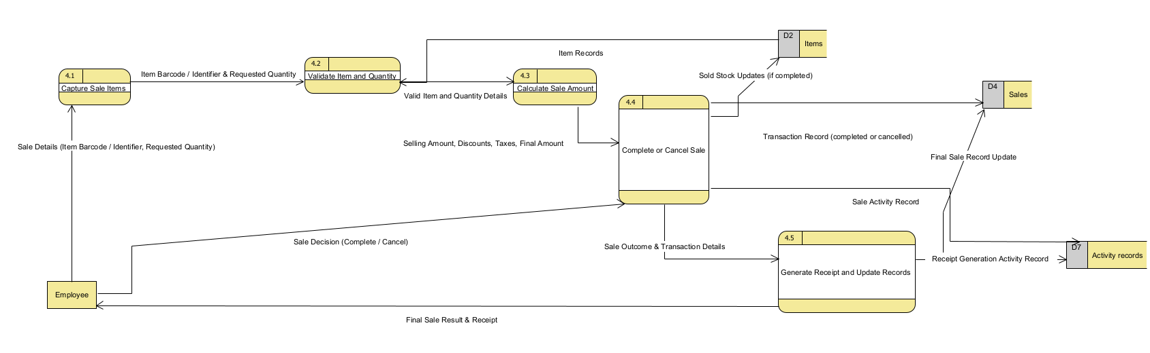
The Visual Paradigm Level 2 diagram decomposes Process 4 into five processes: 4.1 Capture Sale Items; 4.2 Validate Item and Quantity; 4.3 Calculate Sale Amount; 4.4 Complete or Cancel Sale; and 4.5 Generate Receipt and Update Records. The salesperson submits sale item details to 4.1 and a complete/cancel decision to 4.4. Process 4.2 reads item records from D2; 4.4 records completed or cancelled transactions in D4 and posts sold-stock updates to D2 only for completed sales. Process 4.5 produces the final result and receipt for the salesperson and records receipt-generation activity in D7. This paragraph describes the currently drawn model; transaction atomicity and concurrency controls are business rules requiring separate design verification.

4 5 Level 2 balancing and sale rules
Parent process 4 flow | Child endpoint | Balancing review / status
Employee → Sale details and decision → 4 | Employee → Sale Details → 4.1; Employee → Sale Decision → 4.4 | Employee name matches. Two child inputs are grouped at parent level; verify that both sale details and the complete/cancel decision are represented.
4 → Sale result and receipt → Employee | 4.5 → Final Sale Result & Receipt → Employee | External output has the same recipient and meaning; confirm the parent Level 1 label explicitly covers the receipt.
D2 → Item records → 4 | D2 → Item Records → 4.2 | Direction matches; endpoint corrected
4 → Sold stock records → D2 | 4.4 → Sold Stock Updates (if completed) → D2 | Both child writes must be checked for separate purposes; do not assume they are independent records.
4.0 Process Sale → Sale Activity Record → D7 Activity Records (added in updated Level 1) | 4.4 → Sale Activity Record → D7; 4.5 → Receipt Generation Activity Record → D7 | The previously missing Level 1 flow has been added. The two distinct Level 2 activity writes must still be reconciled with the aggregate parent flow and confirmed in the final saved .vpp and Word figures.
Level 1 diagram updated: 4.0 → D7 Sale Activity Record added (15 Oct review); final saved .vpp still requires verification | 4.4 → Sale Activity Record → D7; 4.5 → Receipt Generation Activity Record → D7 | Accepted unchanged by project owner on 15 Oct; D7 parent flow added; final Level 1/2 balancing verification remains OPEN.

Rules applied throughout the models
- Item identifiers and barcodes are unique. Quantities are whole numbers; added, sold, received or replaced quantities must be positive. Removal and sale cannot produce negative inventory.
- An item has a nonnegative selling price. Expiry is optional. Search does not change stock. Viewing expired goods does not remove them automatically.
- A completed sale retains its original price, discount and tax snapshots, so a later price update cannot change old receipts.
- A cancellation is allowed only before completion. Cancelled sale details are retained, but no sold stock record is written.
- Every successful stock change records the actor, quantity change, date, reason and transaction reference. If any part of a stock update fails, the whole operation is undone.
- The system validates current quantities again when committing a transaction. This prevents two counters from both selling the same last unit.

5 Use case model
Use cases are named as goals using a verb and object. Employee is a general actor whose common use cases are inherited by Administrator, Inventory Manager, Store Manager and Salesperson. Supplier participates only in procurement. The following views describe one consistent use case model.
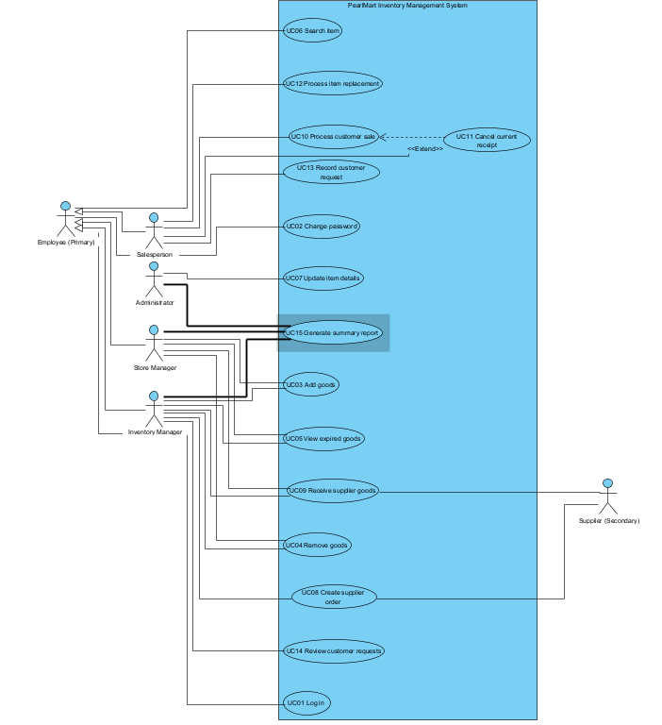
ID | Use case | Actor participation
UC01 | Log in | Employee
UC02 | Change password | Employee
UC03 | Add goods | Inventory Manager; Store Manager
UC04 | Remove goods | Inventory Manager; Store Manager
UC05 | View expired goods | Inventory Manager; Store Manager
UC06 | Search item | Employee
UC07 | Update item details | Administrator
UC08 | Create supplier order | Inventory Manager; Supplier
UC09 | Receive supplier goods | Store Manager; Supplier
UC10 | Process customer sale | Salesperson
UC11 | Cancel current receipt | Salesperson
UC12 | Process item replacement | Salesperson
UC13 | Record customer request | Salesperson; Inventory Manager
UC14 | Review customer requests | Inventory Manager
UC15 | Generate summary report | Administrator; Inventory Manager; Store Manager

5 1 Access and inventory
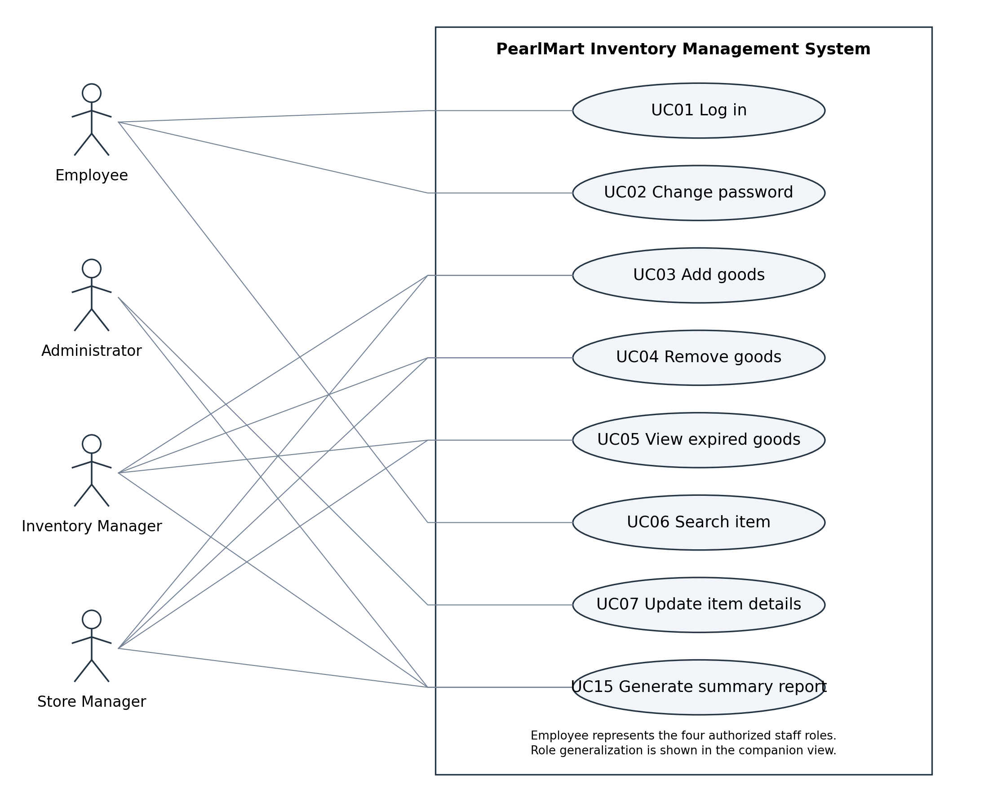
Solid lines show participation. They do not indicate data flow or execution order. The shared Employee associations apply to each specialized staff actor.

5 1 Orders and billing
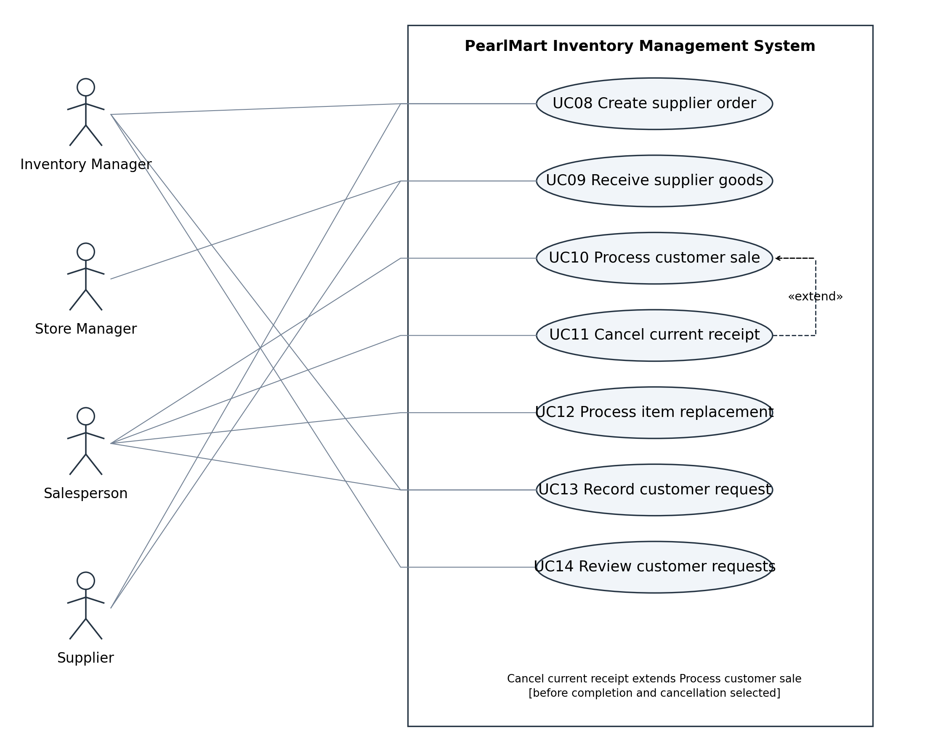
Solid lines show participation. They do not indicate data flow or execution order. The shared Employee associations apply to each specialized staff actor.

5 2 Relationships and comparison

Use case relationship decisions
Cancel current receipt extends Process customer sale. The condition is that the Salesperson chooses cancellation before completion. The extension point is the draft receipt stage. A normal sale can finish without cancellation, so the base use case can stand alone. The dashed arrow points from cancellation to sale.
Employee generalization avoids repeating login, password change and search associations. The hollow triangle points to Employee. We do not use include simply to show the order of actions, and we do not include Log in in every business use case. An authenticated session is a precondition instead. No other include or extend relationship is needed for this simple model.
Question | DFD | Use case model
Main purpose | Shows what data enters, is transformed, stored and returned. | Shows which external roles participate in each goal.
Strength | Makes stock updates and transaction storage visible. | Makes staff responsibilities and system scope easy to review.
Limitation | Does not describe detailed user interaction or execution order. | Does not show stores, data structures or detailed validation.
PearlMart example | P4 shows that a completed sale writes sold stock records and a sale record. | UC10 shows that a Salesperson processes a sale.
For “Does cancellation permanently reduce stock?”, the DFD plus its rules and UC11 flow is more useful because it shows the stock write boundary and when it is permitted. For “Who is allowed to order from suppliers?”, the use case diagram is more useful because it directly associates the Inventory Manager with UC08. Neither diagram by itself proves concurrency or a complete security design.

The following four specifications are substantial business use cases selected from the use case model. Each specification includes a brief description, primary actor(s), trigger, pre-condition(s), post-condition(s), a Main Success Scenario in actor action–system response form, and meaningful alternative flows.

6 UC08 Create supplier order
Brief description: Prepare and send a restocking order to an external supplier.
Primary actor(s): Inventory Manager
Trigger: Additional goods are needed or customer requests suggest replenishment.
Pre-condition(s): The actor is logged in and authorized. A supplier is selected. Each ordered item has a known catalog record; zero-stock items can still be ordered.
Post-condition(s): Success: an order and its lines are stored, necessary information is sent to the supplier, and an activity is recorded. Failure: no incomplete order is presented as sent.

Main Success Scenario
Step | Actor action | System response
1 | Review stock or customer requests. | Display current item information and recorded requests.
2 | Choose the supplier and enter items and quantities. | Check supplier identity, item identifiers and positive quantities.
3 | Enter delivery address, contact information and comments. | Check mandatory fields and display the order for review.
4 | Confirm the order. | Assign an order ID and store the order and lines.
5 | Request order dispatch. | Forward the supplier order, mark it sent when dispatch succeeds and record the activity.
6 | Read the result. | Display order ID and current status.

Alternative flows
2a Invalid item or quantity: Reject the affected line and allow correction; no sent order is created.
3a Missing delivery information: List the missing fields and return to step 3.
4a User cancels: End without sending or posting a new order.
5a Dispatch fails: Keep the order as pending dispatch and show the failure. Retry the same order ID to avoid creating a duplicate.

6 UC09 Receive supplier goods
Brief description: Verify delivered goods and record the accepted quantities in inventory.
Primary actor(s): Store Manager; Supplier provides supporting invoice and goods details
Trigger: Goods arrive for a recorded supplier order.
Pre-condition(s): The Store Manager is logged in. The order exists and has outstanding quantities. Supplier goods and invoice information are available.
Post-condition(s): Success: verified quantities are recorded, item stock is increased, order receipt totals are updated, and activity is stored together. Failure: no partial stock posting remains.

Main Success Scenario
Step | Actor action | System response
1 | Enter the order and supplier invoice reference. | Retrieve the order, existing invoice data and outstanding quantities.
2 | Compare delivered goods with the order and invoice. | Display item identifiers, expected quantities and invoice prices.
3 | Scan each item and enter the quantity actually accepted. | Check item identity, positive quantity and remaining ordered quantity.
4 | Verify item data and the delivered expiry date where applicable. | Check identifier, barcode, price, origin, manufacturer and the expiry assumption A03.
5 | Confirm the verified receipt. | Reject duplicate receipt references and recheck remaining quantities.
6 | Read the confirmation. | Save the invoice and goods receipt, increase stock, update order status and record activity as one operation.

Alternative flows
1a Unknown order or duplicate invoice: Stop and show the existing reference or missing order. Do not duplicate its financial or stock records.
3a Short delivery: Record the smaller accepted quantity and keep the remaining order quantity open.
3b Excess, damaged or unexpected goods: Do not post those goods. Correct the accepted quantities or resolve the discrepancy with the supplier.
4a Different expiry for an existing item: Hold the affected line and obtain the instructor-approved expiry approach under A03.
5a Duplicate receipt or concurrent receipt: Reject a duplicate or recheck the updated outstanding quantities; do not post twice.
6a Save failure: Undo the whole receipt posting and let the actor retry safely.

6 UC10 Process customer sale
Brief description: Create a priced customer sale and complete it with a receipt and consistent stock.
Primary actor(s): Salesperson
Trigger: A customer presents items at the billing counter.
Pre-condition(s): The Salesperson is logged in and authorized. The system has item records and approved discount and tax settings.
Post-condition(s): Success: a completed sale and receipt are recorded; purchased quantities are deducted once and activity is stored. Cancellation or failure: no permanent stock deduction.

Main Success Scenario
Step | Actor action | System response
1 | Scan an item or enter its identifier and quantity. | Find the item and validate quantity, expiry and available stock.
2 | Continue adding or correcting the selected items. | Maintain draft sale lines and display the current unit prices and subtotals.
3 | Finish entering the items. | Apply approved discounts and taxes and calculate the final total.
4 | Review the total and confirm successful payment outside this system. | Keep the draft open until completion is confirmed.
5 | Confirm completion. | Revalidate current stock and save the sale, deductions and activity together.
6 | Give the receipt to the customer. | Generate receipt details including items, quantities, prices, discounts, taxes and final amount.

Alternative flows
1a Item not found or expired: Show an error and exclude that line until corrected.
1b Insufficient quantity: Show available stock; the actor may reduce quantity or remove the line.
Before step 5 Cancellation: UC11 extends this use case. Record cancelled status and reason, discard draft deductions and return confirmation.
5a Stock changed at another counter: Do not complete; show the shortage and return for correction.
5b Save failure: Undo the sale and stock posting together. Retry only after checking the transaction reference.
6a Receipt output fails: Keep the completed transaction and regenerate its receipt; do not deduct stock again.

6 UC12 Process item replacement
Brief description: Verify a customer replacement request and update the affected inventory.
Primary actor(s): Salesperson
Trigger: A customer asks to replace a purchased item.
Pre-condition(s): The Salesperson is logged in. A completed original sale and purchased line can be identified. The proposed policy A06 is approved.
Post-condition(s): Success: a replacement is linked to the original sale line, outgoing stock is reduced, a resalable return is added when appropriate, and activity is recorded. Failure: no stock or replacement changes remain.

Main Success Scenario
Step | Actor action | System response
1 | Enter the original receipt and purchased item. | Retrieve the completed sale line and its previous replacements.
2 | Enter replacement quantity and reason. | Check that quantity is positive and does not exceed purchased quantity minus previously accepted replacements.
3 | Inspect the returned item and record whether it can be resold. | Validate the proposed like for like replacement and record its disposition.
4 | Select the replacement item. | Check the same item identity, current stock and expiry; replacement stock must exist before posting the returned unit.
5 | Confirm the accepted replacement. | Recheck eligibility and atomically deduct outgoing stock, add only a resalable return, and store the replacement and activity.
6 | Read the result. | Display the replacement reference and updated stock.

Alternative flows
1a Missing or cancelled receipt: Reject the request and explain why it cannot be verified.
2a Too many units or previously replaced units: Reject excess quantity; do not replace the same purchased quantity twice.
3a Policy does not allow replacement: Record the rejection result for the actor without a stock update.
4a Replacement unavailable or expired: Do not post the replacement. A separate customer request may be recorded under UC13.
5a Concurrent replacement or save failure: Recheck remaining eligibility; undo all changes if the operation cannot complete.

7 Design class model
The design separates business objects from application services. Domain objects hold item, order and transaction data. Services coordinate validation, authorization and updates across those objects. There are no framework, database table or supplier internal classes.
Attributes are private (−) and operations are public (+). String, Integer, Decimal, Boolean, Date and DateTime are simple data types. “void” means no return value; [0..1] means optional and [0..*] means a collection. Role has Administrator, InventoryManager, StoreManager and Salesperson values. Transaction is abstract; its getSummary operation is implemented by Sale, Replacement and StockMovement.
A persisted sale has at least one line. A draft in memory may briefly have zero lines; it is not completed or stored as a valid receipt until it has at least one. Order, invoice and goods receipt line collections are also nonempty for a valid stored document.

Responsibilities and object oriented principles
Item owns stock and price rules. Its methods reject invalid quantities and prices, so callers do not directly overwrite private fields. This is encapsulation. SaleLine stores the selling price at the time of purchase; changing Item.sellingPrice does not change an earlier sale.
SalesService coordinates sale validation, pricing, completion, stock movement records and receipt generation. ProcurementService coordinates orders, invoices and receipts. ReplacementService coordinates original sale checks and stock effects. These responsibilities are split into modules that can be reviewed separately.
Transaction abstracts common identity, time, status and summary behavior. Sale, Replacement and StockMovement specialize it because each is a recorded business transaction with that common data. User roles use a Role value rather than four nearly identical User subclasses; role permissions are checked by services.
Composition is used for Sale to SaleLine, SupplierOrder to OrderLine, SupplierInvoice to InvoiceLine and GoodsReceipt to ReceiptLine. A line has no meaningful independent lifecycle outside its owning document. Supplier aggregates orders: orders belong to that supplier’s history but must remain retained even if the supplier is no longer active. Other connections are ordinary associations.
All stock-changing services validate permissions and perform their related changes together. The class diagram expresses responsibilities; the atomicity rule is a required behavior, not a choice of database or implementation framework. ActivityRecord stores the operational history used by ReportService.

Reading the diagram views
The next views show the same model. A class repeated in a relationship view is a reference, not a new class. The relationship views provide all domain multiplicities. The service dependency table completes the application connections without drawing long crossing arrows over the domain classes.

7 1 Users and items
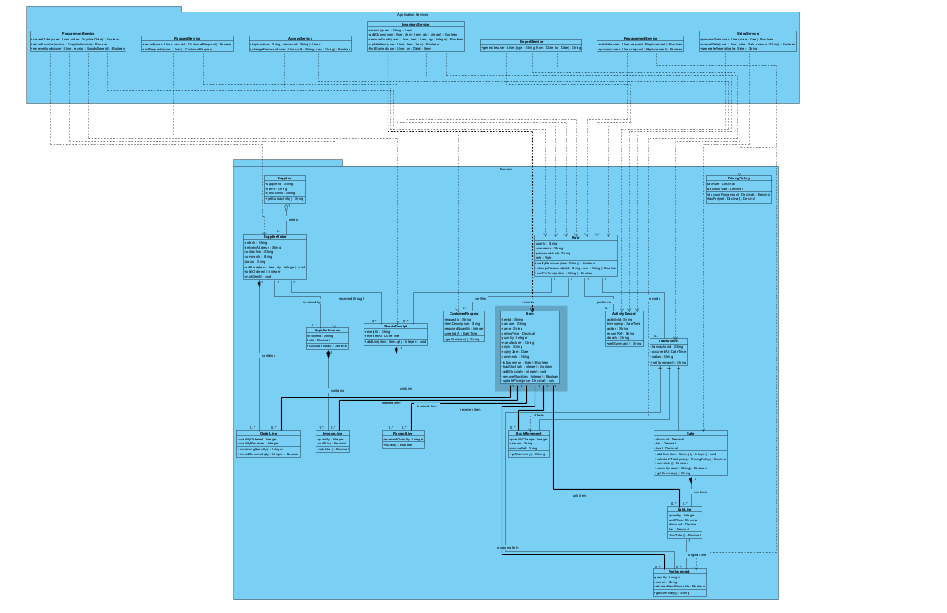
− private attribute + public operation Hollow triangle: child to parent Filled diamond: composition Hollow diamond: aggregation

7 1 Transaction abstraction
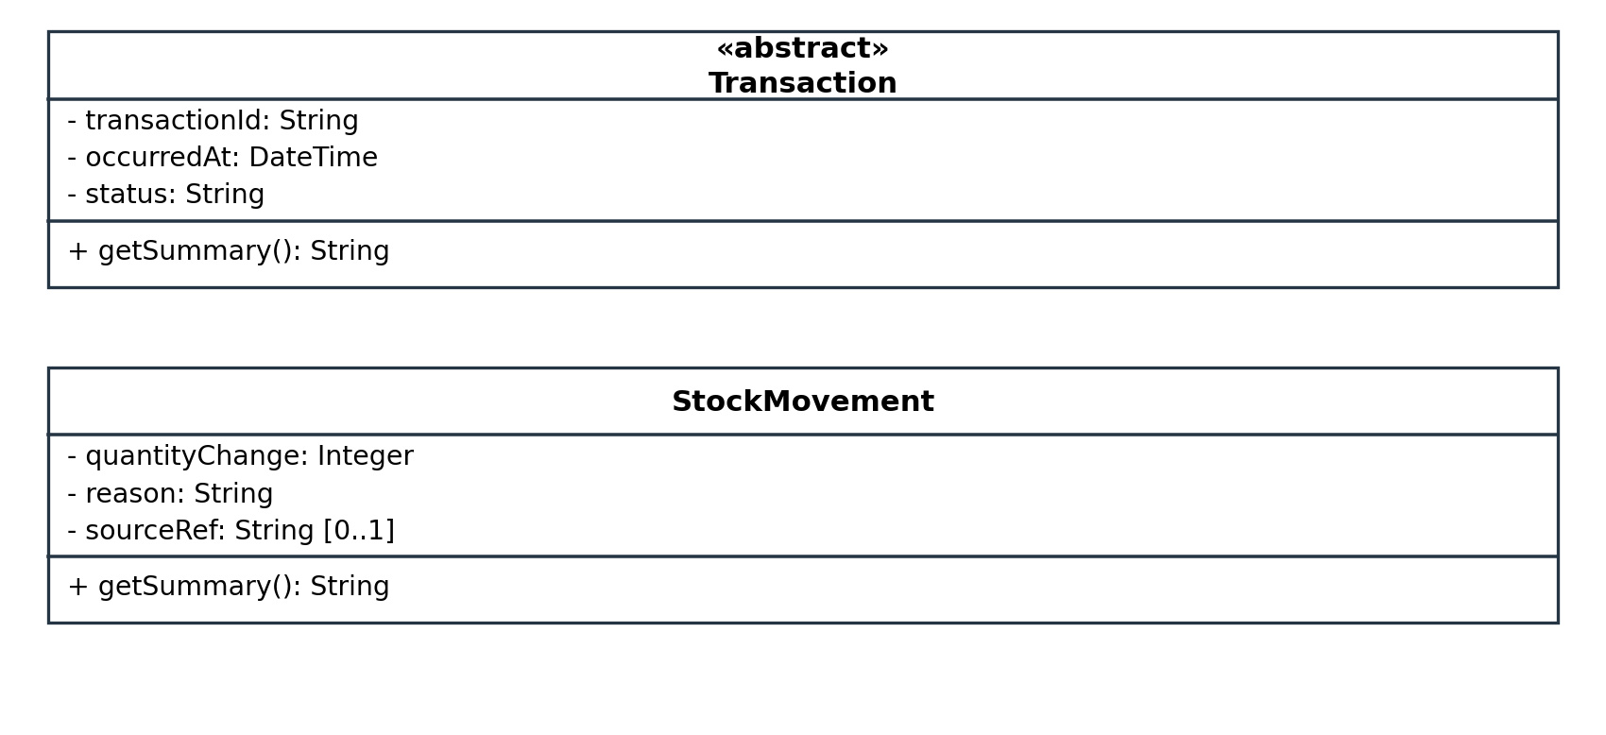
− private attribute + public operation Hollow triangle: child to parent Filled diamond: composition Hollow diamond: aggregation

7 1 Orders and suppliers
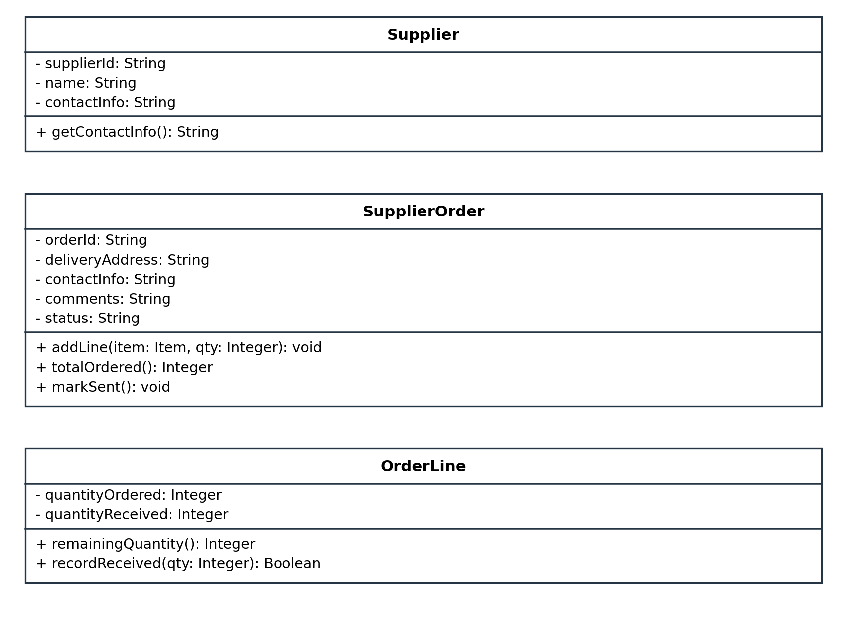
− private attribute + public operation Hollow triangle: child to parent Filled diamond: composition Hollow diamond: aggregation

7 1 Invoices and receipts
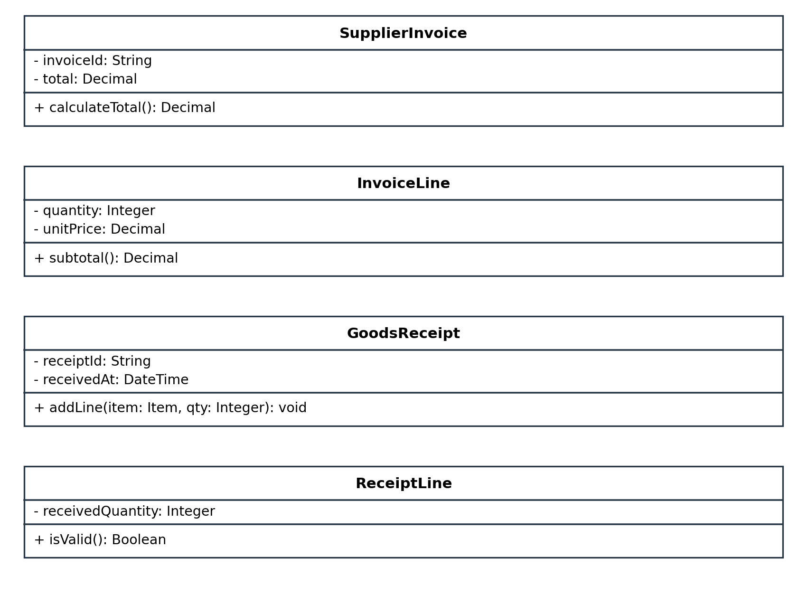
− private attribute + public operation Hollow triangle: child to parent Filled diamond: composition Hollow diamond: aggregation

7 1 Sales and sale lines
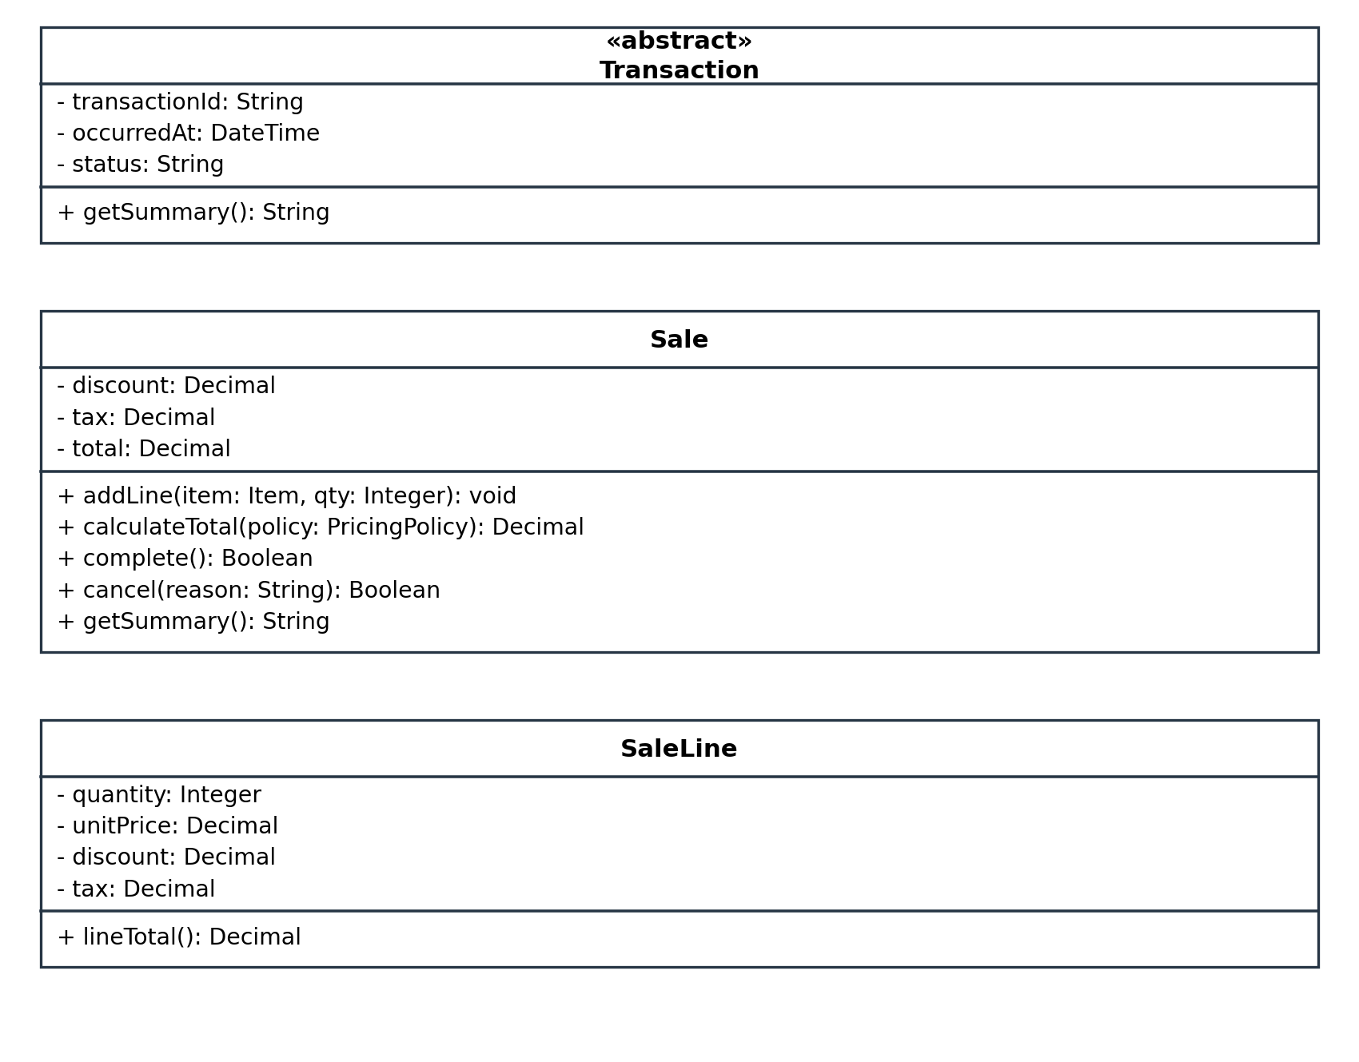
− private attribute + public operation Hollow triangle: child to parent Filled diamond: composition Hollow diamond: aggregation

7 1 Replacements and items
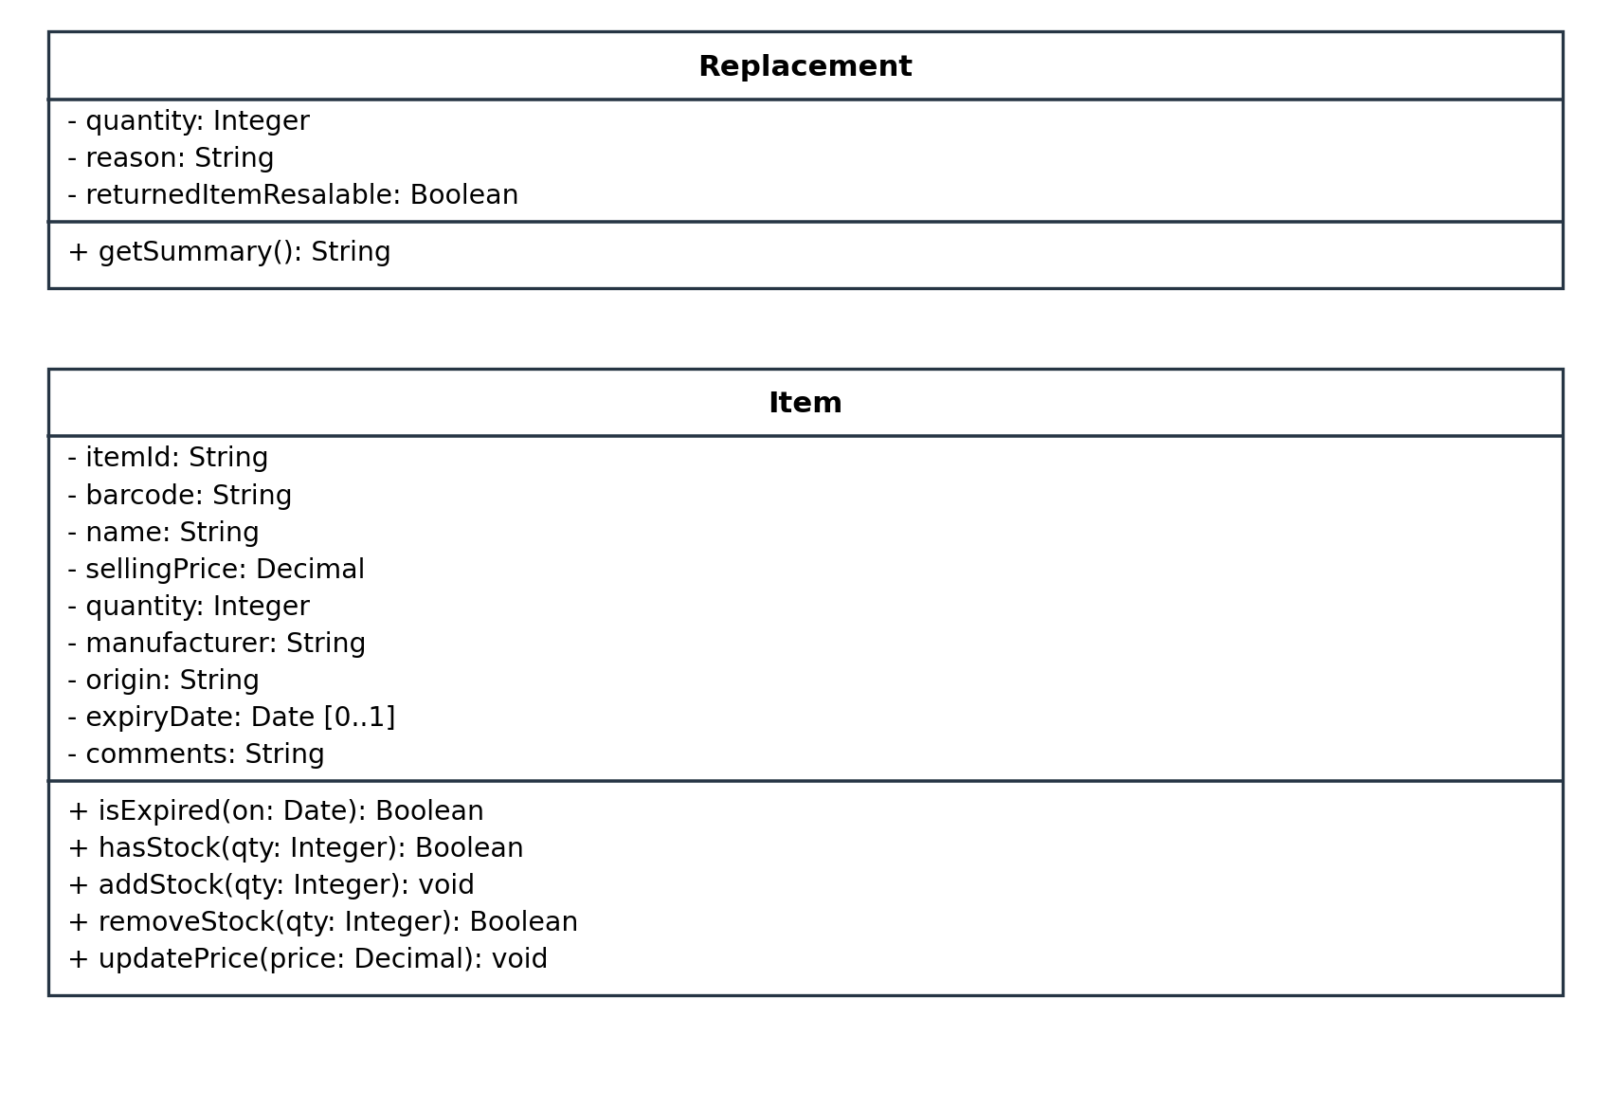
− private attribute + public operation Hollow triangle: child to parent Filled diamond: composition Hollow diamond: aggregation

7 1 Requests and history
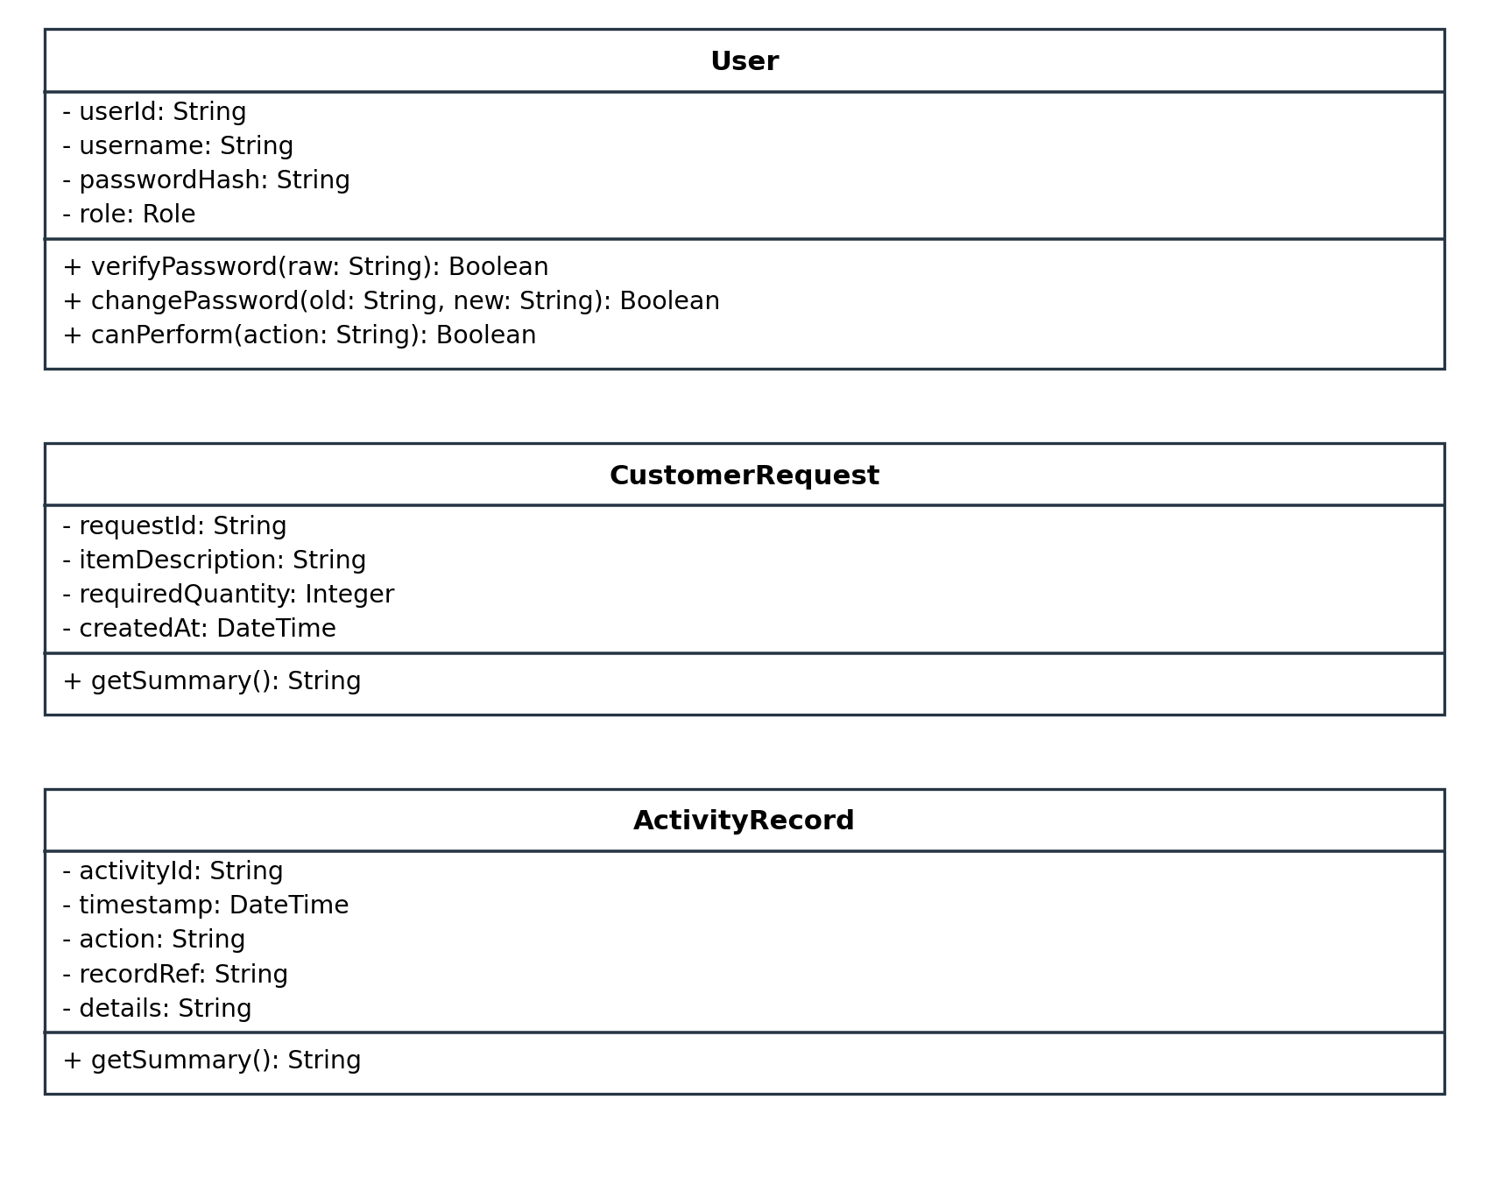
− private attribute + public operation Hollow triangle: child to parent Filled diamond: composition Hollow diamond: aggregation

7 1 Application services part one
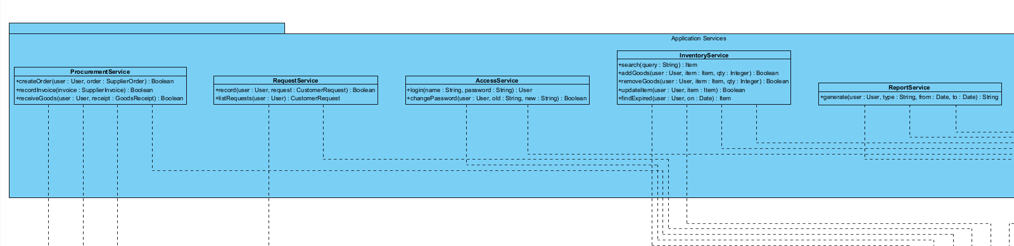
− private attribute + public operation Hollow triangle: child to parent Filled diamond: composition Hollow diamond: aggregation

7 1 Application services part two
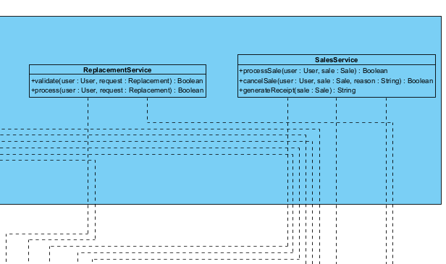
− private attribute + public operation Hollow triangle: child to parent Filled diamond: composition Hollow diamond: aggregation

7 2 Domain relationships view 1
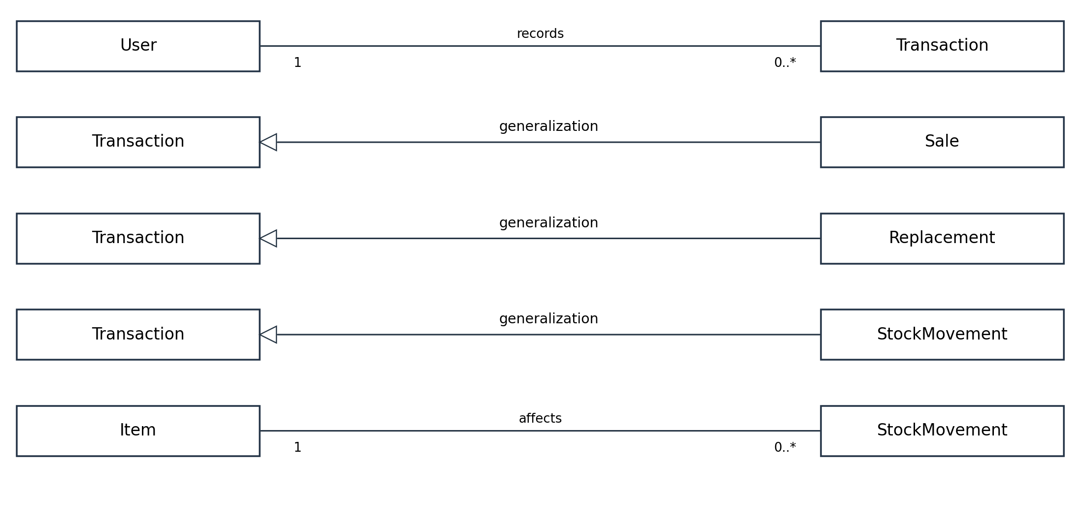
Multiplicities are written next to their corresponding class ends. A relationship row is a readable view of the same complete model.

7 2 Domain relationships view 2
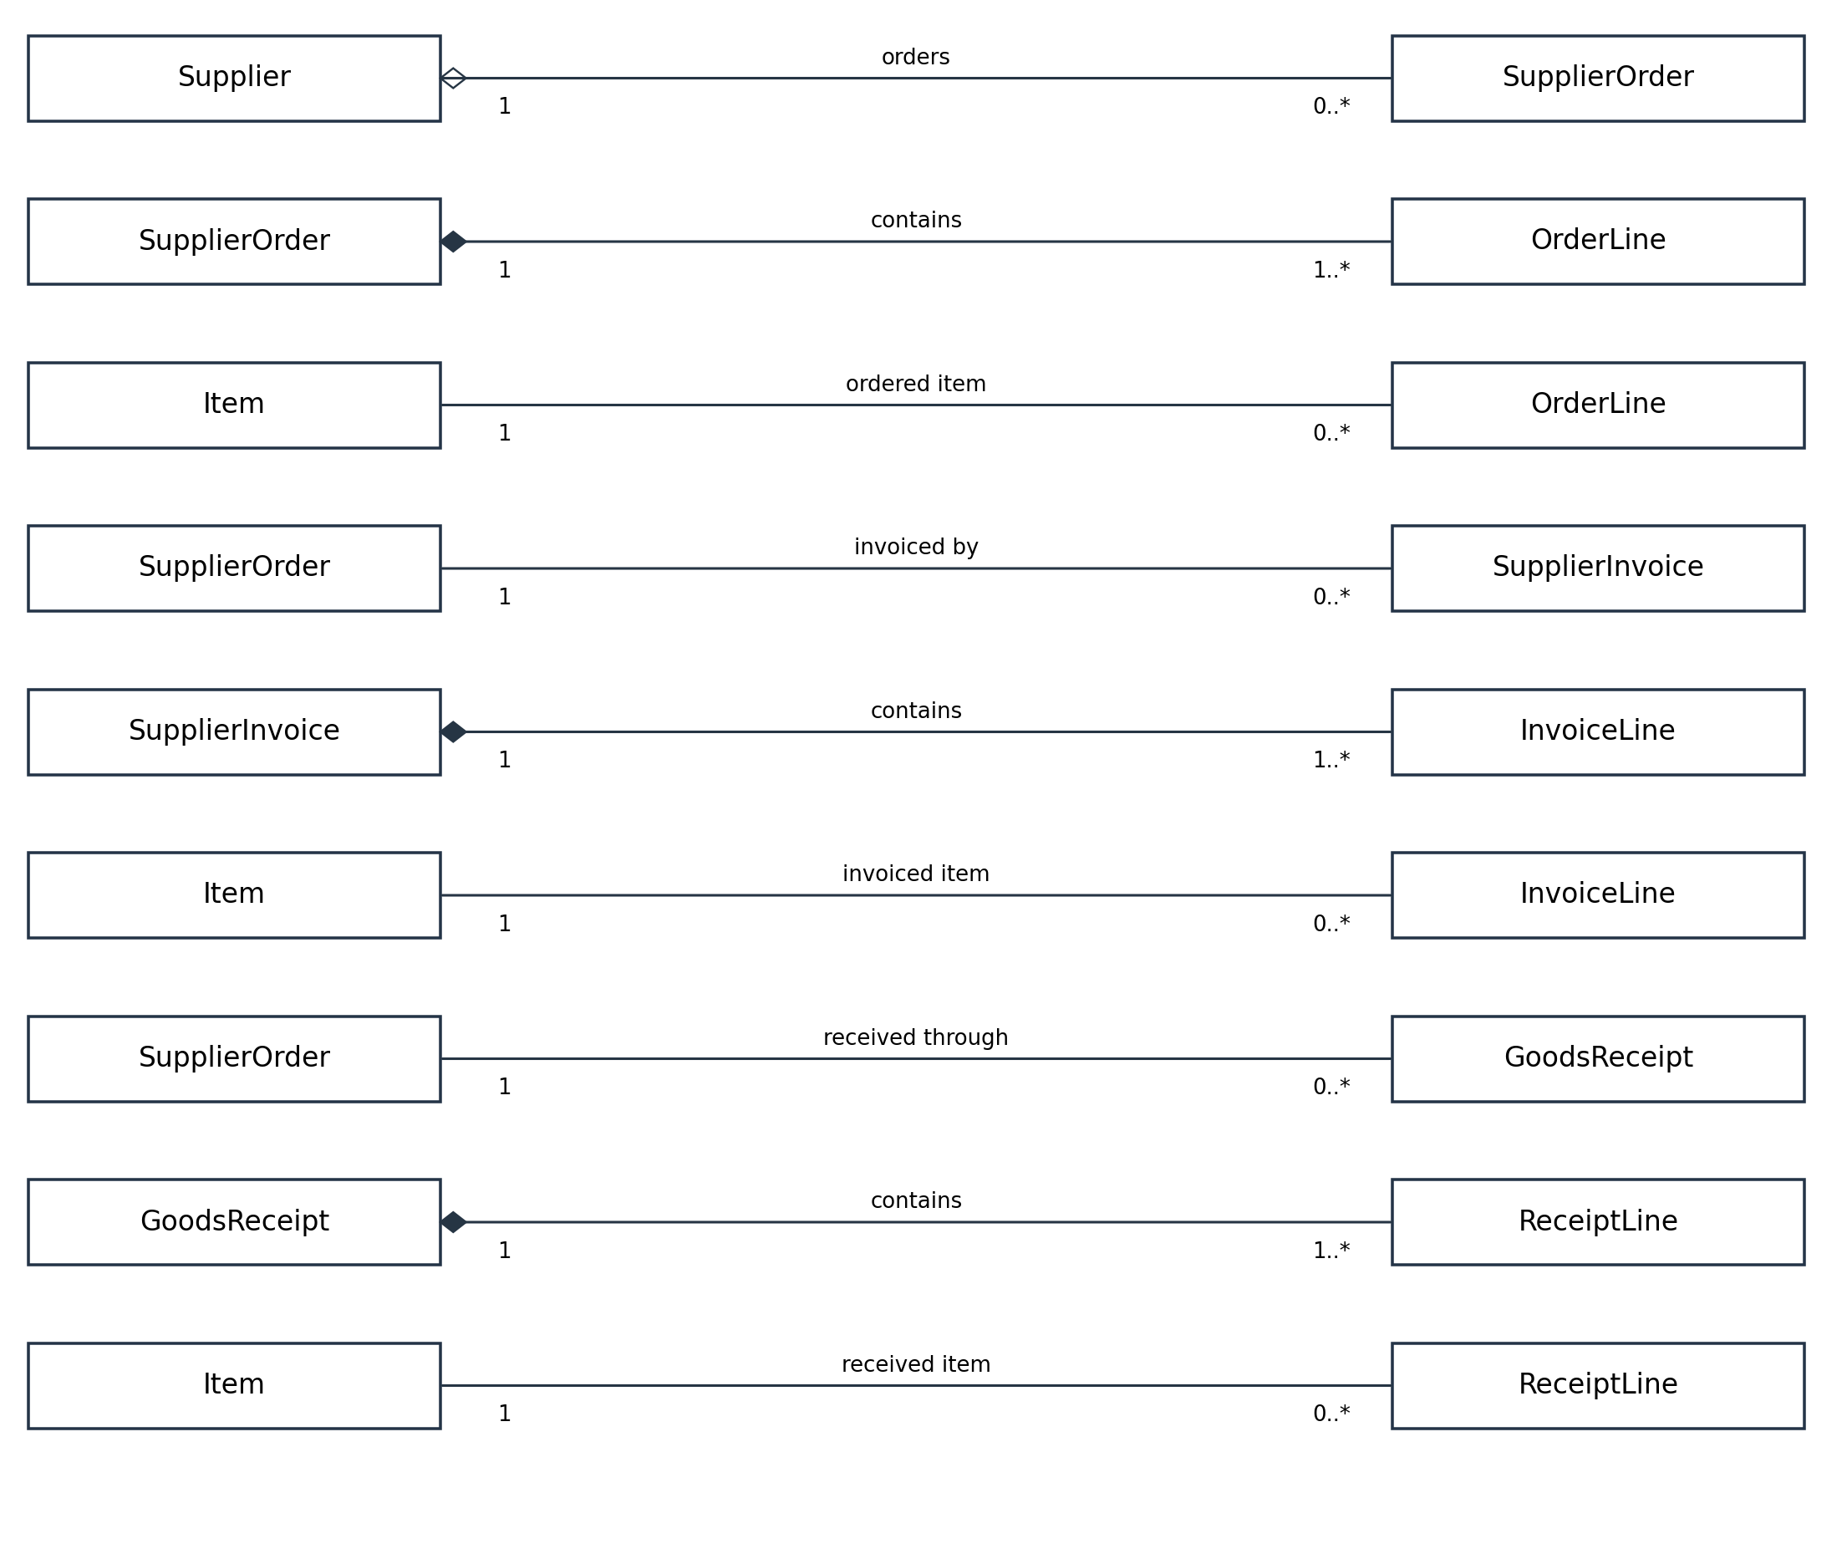
Multiplicities are written next to their corresponding class ends. A relationship row is a readable view of the same complete model.

7 2 Domain relationships view 3
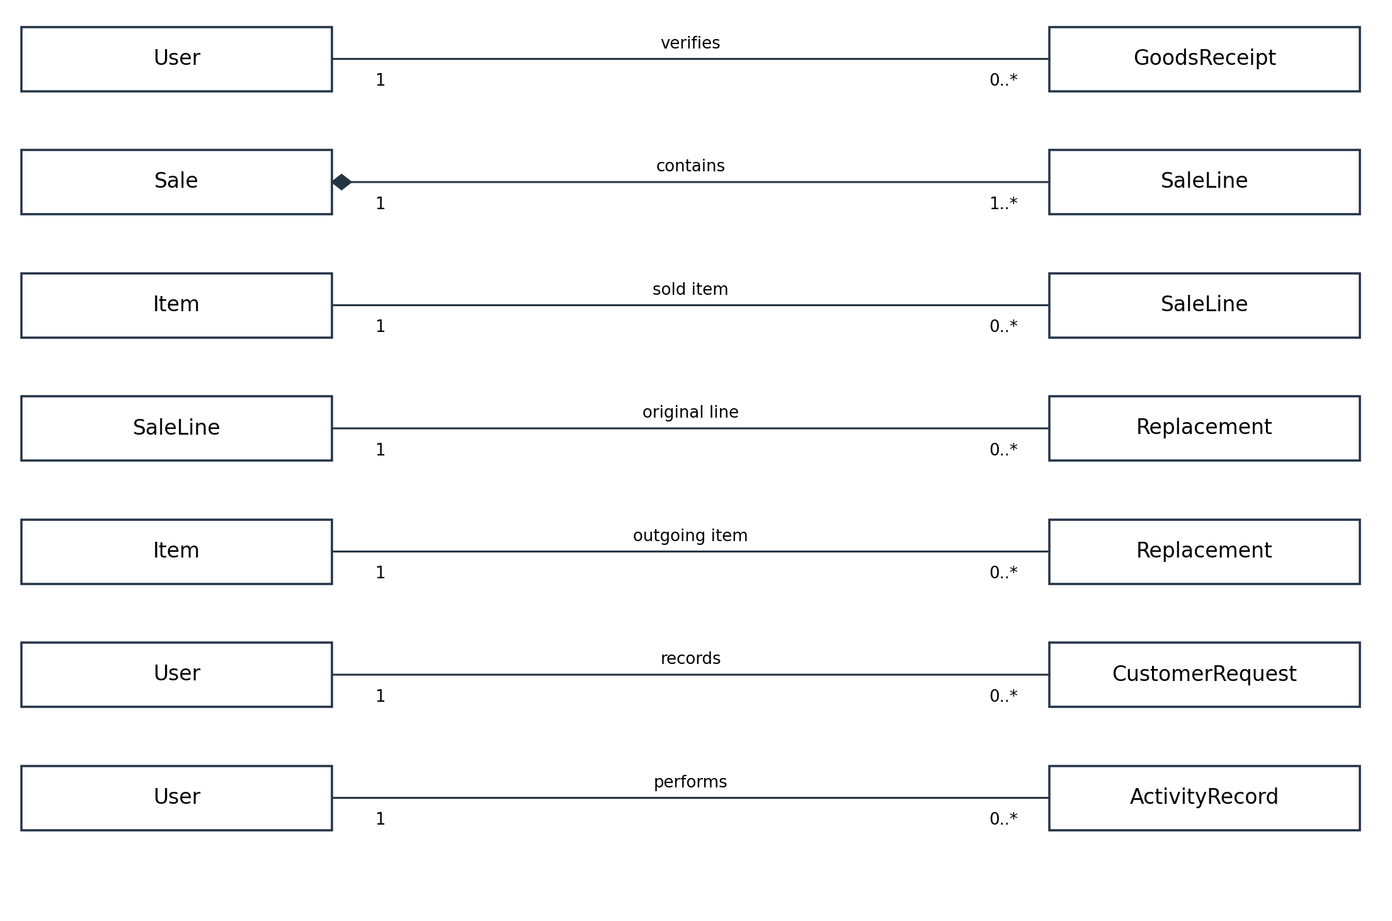
Multiplicities are written next to their corresponding class ends. A relationship row is a readable view of the same complete model.

7 3 Application dependencies
Application class | Depends on | Responsibility
AccessService | User | Verify credentials and change passwords.
InventoryService | User, Item, StockMovement, ActivityRecord | Authorize, validate, update inventory and record history.
ProcurementService | User, Supplier, SupplierOrder, OrderLine, SupplierInvoice, InvoiceLine, GoodsReceipt, ReceiptLine, Item, StockMovement, ActivityRecord | Create orders, record invoice data and receive goods.
SalesService | User, Sale, SaleLine, Item, PricingPolicy, StockMovement, ActivityRecord | Validate and price sales, complete or cancel, produce receipt text.
ReplacementService | User, Sale, SaleLine, Replacement, Item, StockMovement, ActivityRecord | Check original purchase and previous replacements; update stock.
RequestService | User, CustomerRequest, ActivityRecord | Record and retrieve customer requests.
ReportService | User, Item, SupplierOrder, SupplierInvoice, GoodsReceipt, Sale, Replacement, CustomerRequest, StockMovement, ActivityRecord | Read relevant records and generate a summary.
In Visual Paradigm, draw these as dashed dependencies from each service to its used classes. Dependencies have no multiplicity. Keep separate service views to preserve readability. Report generation returns a report representation; it does not create a persistent Report entity. Receipt text is generated from the retained Sale and SaleLine data, so it also needs no duplicate domain object.

Key invariants
quantity ≥ 0; quantityOrdered > 0; 0 ≤ quantityReceived ≤ quantityOrdered; replacement quantity ≤ original purchased quantity minus earlier accepted replacements. A replacement’s outgoing Item must match the original SaleLine Item under A06. Each invoice and goods receipt belongs to one supplier order. Each transaction, request and activity has one recording user. Each stock movement affects one item.

8 Requirement traceability
Req | Use cases | DFD | Responsible classes
R01 | UC01 UC02 | 1 | User; AccessService
R02 | UC03 | 2 | Item; InventoryService; StockMovement
R03 | UC04 | 2 | Item; InventoryService; StockMovement
R04 | UC05 UC04 | 2 | Item; InventoryService
R05 | UC06 | 2 | Item; InventoryService
R06 | UC07 | 2 | Item; InventoryService
R07 | UC08 | 3 | SupplierOrder; OrderLine; ProcurementService
R08 | UC09 | 3 | SupplierInvoice; GoodsReceipt; ProcurementService
R09 | UC10 | 4 | Sale; SaleLine; PricingPolicy; SalesService
R10 | UC10 | 4 | Sale; Item; StockMovement; SalesService
R11 | UC11 | 4 | Sale; SalesService; ActivityRecord
R12 | UC12 | 5 | Replacement; SaleLine; ReplacementService
R13 | UC13 UC14 | 6 | CustomerRequest; RequestService
R14 | UC15 | 7; writes in 2–6 | ActivityRecord; ReportService
R15 | UC03 UC04 UC09 UC10 UC12 | 2 3 4 5 | Item; application services
Cross model check: UC08 and UC09 use P3 and procurement classes. UC10 and UC11 share P4 and Sale. UC12 uses P5 and Replacement. Every persistent store is represented by the matching domain objects, and every business area has an application service. R15 applies across the stock-changing services and is a behavioral consistency rule.

9 Scrum plan
The team used two planned Scrum iterations to organize requirements, data-flow modeling, use-case design, class design and report integration. GitHub issues and pull requests provide the project activity record.
Team member | Scrum responsibility | Development responsibility
Aljazi Alnoaimi  GitHub: aljazi20 | Product Owner and Developer | Scope, use cases, core class design and report integration
Dhuha Almalki  GitHub: Dhuha2767 | Scrum Master and Developer | Context model, procurement specifications and evidence tracking
Buthaina Albaye  GitHub: buthaiinah | Developer | Level 1, sale specifications and application classes
Aldana Al-Mamari  GitHub: AldanaAlmamari | Developer | Level 2, balancing, traceability and release checks

Product Goal
Produce a reviewed and consistent requirements and design baseline for PearlMart that explains inventory operations at the warehouse and billing counters and can guide the next development milestone.

Definition of Done
- The issue acceptance criteria are met and the assignee has checked the affected requirements.
- The relevant Word content and native Visual Paradigm model are consistent and readable.
- Assumptions, diagrams, specifications and traceability have been updated together.
- A teammate has provided a substantive review, corrections are resolved and the pull request is merged to main.
- The issue, branch, pull request and final artifact are linked. The Project status is Done and necessary evidence is saved.
Sprint | Dates and checkpoint | Goal | Selected work
Sprint 1 | Sprint 1: actual dates to confirm; record real review and retrospective dates (do not backdate). | Review the scope, DFDs, use case model and four specifications. | B01–B08
Sprint 2 | Sprint 2: actual dates to confirm; complete review, retrospective and release verification by 18 October 2026, 23:59. | Complete and verify class design, cross model consistency and submission package. | B09–B16
Both Sprints are shorter than two weeks and end before the 18 October deadline. Estimates are planning hours, not proof of contributions. Reestimate if the team needs more time to reproduce models or respond to feedback.

9 1 Product and Sprint backlogs
ID | Work item | Owner / reviewer | Sprint | Hours
B01 | Confirm scope and assumptions | Aljazi / Dhuha | 1 | 2
B02 | Model Level 0 and flow inventory | Dhuha / Buthaina | 1 | 3
B03 | Model Level 1 and stores | Buthaina / Aldana | 1 | 4
B04 | Model sale Level 2 and balancing | Aldana / Aljazi | 1 | 3
B05 | Model use cases and permissions | Aljazi / Dhuha | 1 | 3
B06 | Write order and receiving specifications | Dhuha / Buthaina | 1 | 3
B07 | Write sale and replacement specifications | Buthaina / Aldana | 1 | 3
B08 | Review Sprint 1 and improve plan | Aldana / Aljazi | 1 | 2
B09 | Design inventory and transaction classes | Aljazi / Buthaina | 2 | 4
B10 | Design procurement and record classes | Dhuha / Aldana | 2 | 4
B11 | Design application responsibilities | Buthaina / Aljazi | 2 | 3
B12 | Check traceability and model consistency | Aldana / Dhuha | 2 | 3
B13 | Integrate report and native Visual Paradigm project | Aljazi / Aldana | 2 | 3
B14 | Capture evidence and validate repository files | Dhuha / Aljazi | 2 | 3
B15 | Conduct Sprint 2 review and retrospective | Buthaina / Dhuha | 2 | 2
B16 | Verify final release files and submission links | Aldana / Buthaina | 2 | 2
The backlog below is the agreed working plan for the two Sprints. Each item has one owner and a different reviewer, with estimates and Sprint allocation. GitHub issue numbers, labels, milestone links and final status must reflect the team’s actual repository activity.
Member | Planned hours | Substantive peer reviews
Aljazi | 12 | B04, B08, B11, B14
Dhuha | 13 | B01, B05, B12, B15
Buthaina | 12 | B02, B06, B09, B16
Aldana | 10 | B03, B07, B10, B13

9 2 GitHub execution workflow
- Use the private, instructor-assigned repository in cmps310fall26. Do not create a substitute repository. Add the four real team members and keep each member on their own account.
- Copy the supplied README, .gitignore and .github templates into the repository after checking existing files. Fill in team details and the GitHub Project URL.
- Create the Milestone-1 milestone with due date 18 October 2026. Create Issues from the provided drafts; B01–B16 are planning IDs, not actual GitHub issue numbers.
- For each issue, set one actual assignee, type: docs, priority: high, the appropriate phase label, and the milestone. Add it to the GitHub Project.
- Configure Status as Todo, In Progress, In Review and Done. Add Sprint or Iteration, Estimate in hours, Start date and Target date fields. Create a board, Table grouped by Assignees, and Roadmap.
- Start each task by creating a linked branch from the issue. Set In Progress. Make the actual changes and reference the issue number in commits.
- Open a pull request with Closes #actual-issue-number and set In Review. Another member reviews the actual artifact and asks for or verifies corrections. Merge only after review.
- Set Done when the agreed definition is met. Save dated evidence during both Sprints. Record review and retrospective notes when they occur.
- Coordinate one editor at a time for Word and .vpp files. Pull the latest main before editing. Resolve conflicting model changes together rather than merging binary files blindly.
- Before release, verify the .vpp opens and matches all report diagrams. Commit the final files and required evidence inside Milestone-1 on main. Record repository, Project, milestone and final commit URLs.

10 Scrum evidence and final team completion
Project evidence is maintained through the repository issue history, pull requests, milestone deliverables and the Scrum project board.
ID | Capture point | Evidence required
E01 | Start of Sprint 1 | Product Backlog with priorities, labels, assignees and estimates
E02 | During Sprint 1 | Sprint board and dated status transitions or activity history
E03 | Sprint 1 review — actual date to confirm | Sprint 1 review feedback, retrospective and selected improvement
E04 | Start of Sprint 2 | Sprint 2 backlog and how it incorporates the selected improvement
E05 | During Sprint 2 | Current board, dated changes and substantive teammate reviews
E06 | Before final release | Table grouped by Assignees with estimates and Roadmap with dates
E07 | Sprint 2 review — actual date to confirm | Sprint 2 review, retrospective and evidence of applied improvement
E08 | At final release | Each member’s issue → branch → reviewed PR → final artifact links

Submission links
Assigned repository URL: https://github.com/buthaiinah/team-3-b52 (team repository observed; confirm instructor assignment)
GitHub Project URL: https://github.com/users/buthaiinah/projects/2
Milestone-1 URL: https://github.com/buthaiinah/team-3-b52/tree/main/Milestone-1
Release reference: see the Milestone-1 directory and the main branch commit history for the latest submitted report and Visual Paradigm project.

10.1 Sprint 1 review and retrospective
Sprint 1 review focused on project scope, requirements, DFDs, the use-case model and detailed use-case specifications. The review established consistency checks for the subsequent design work.

Actual dates and attendees
Review window: 9 October 2026 (planned). Team: Aljazi Alnoaimi, Dhuha Almalki, Buthaina Albaye and Aldana Al-Mamari. Attendance is not independently documented in the repository evidence.

Sprint Goal result
Sprint 1 produced the initial project scope, DFDs, use-case model and four detailed use-case specifications. Identified cross-model consistency topics were carried into the following iteration.

Completed issue and pull request links

Incomplete items and next action
Remaining work included cross-model consistency checks and verification of the Visual Paradigm source against the report diagrams.

Review feedback from the team or instructor
Review criteria included consistent process, use-case and class names, balanced DFD interfaces, and alignment between the Word report and the native Visual Paradigm model.

Difficulties and their effect
A key coordination risk was conflicting changes to the Word report and the binary Visual Paradigm file. Sequential editing and synchronization with the main branch were used as version-control practices.

Retrospective improvement action with owner and target date
The team introduced a shared model-consistency checklist for peer review, with Aldana responsible for the traceability review and Aljazi providing product-level review.

Improvement transferred to Sprint 2
The consistency checklist informed the B12 traceability/model-consistency task and B13 report/Visual Paradigm integration work in Sprint 2.

10.2 Sprint 2 review and retrospective
Sprint 2 review documents the completed design and integration work and distinguishes it from the remaining release evidence tasks.

Actual dates and attendees
Review window: 16 October 2026 (planned). Team roles: Aljazi (Product Owner), Dhuha (Scrum Master), Buthaina and Aldana (Developers). Attendance is not independently documented.

Sprint Goal result
Sprint 2 addressed class design, traceability review and integration of the report with the Visual Paradigm source. Final release verification is tracked separately in the remaining repository tasks.

Completed issue and pull request links

Incomplete items and next action
B14 evidence capture and B15 Sprint 2 review documentation have been completed. B16 final release verification remains in progress.

Review feedback from the team or instructor
The review criteria were readable diagrams, consistent terminology, complete requirements traceability, and alignment of the Word report with the native .vpp project.

Difficulties and their effect
Coordinating GitHub evidence, the Word report and the Visual Paradigm source was the principal integration challenge. The team used an issue-based review and release checklist to reduce mismatched artifacts.

Retrospective improvement action with owner and target date
The Scrum Master coordinates a shared consistency and release checklist as a standard pre-merge practice for subsequent milestones.

How Sprint 1 improvement was applied
The shared consistency checklist informed B12 and B13 review activities; the merged pull requests and final diagram files provide the supporting implementation history.

GitHub evidence: the project repository records the B12 and B13 integration work and subsequent review pull requests. See the main branch and issue history for the latest merged versions.
Release note (16 Oct 2026): The latest DFD Level 0, Level 1, Level 2, Use Case, and Class Diagram screenshots have been uploaded to the repository. The native Visual Paradigm project is also available in the Milestone-1 directory. Final report verification and submission link checks are tracked under B16.

